|  |  |  |
| --- | --- | --- |
| Republique du Cameroun |  | Republic of Cameroon |
| *************** | *************** |
| Paix-Travail-Patrie | Peace-Work-Fatherland |
| *************** | *************** |
| Ministere de enseigment superieure | Ministry of High Education |
| *************** | *************** |
| Universite de Buea | University of Buea |
| *************** | *************** |
|  | Faculty of Engineering and Technology |
|  |  |
|  | Department of Computer Engineering |
|  |  |

**CEF 440 INTERNET AND MOBILE PROGRAMMING**

**PROJECT REPORT**

**PRESENT BY:**

|  |  |  |
| --- | --- | --- |
| **NAMES** | | **MATRICULES** |
| **GUEGUIM SONNA ZITHA UNELLE** | | **FE20A045** |
| **MAKONDI THIERRY JUNIOR** | | **FE20A062** |
| **NGANKEP FANDIO ORDY BENIDI** | | **FE20A075** |
| **HIEGA EMMANUEL JOEL** | | **FE20A050** |
| **OMYOM KILLENG ZACHARIE FRANKLIN** | **FE20A096** | |

Abstract:

The system we are working on is a software that will help customers to view the price of different products on the market. This is to help them to better plan their move by providing them with the real price of the product and where they can get it. To achieve this, we will fist need to have the price of various product in all the market in Cameroon. So, for us to collect price of different product, we plan to build a software in which vendors upload their product and price plus their location on the software and customer can see those information. In the following line, we will present the UML diagram(activity diagram, data flow diagram, use case diagram, sequence diagram and class diagram) that we made for this project to better visualize the project for a better implementation.

Table of Contents:

1. Introduction
2. User Research and Analysis
3. Information Architecture
4. Visual Design
5. Interaction Design
6. Usability Testing and Evaluation
7. Implementation and Development
8. Conclusion

**Executive Summary:**

This UI/UX Design Report provides a comprehensive overview of the design process and considerations for the Market Management System. The report highlights the key aspects of user research, information architecture, visual design, interaction design, and usability testing. The findings and recommendations presented in this report aim to deliver an intuitive and engaging user interface, ensuring a seamless user experience for market managers.

Introduction

The purpose of this UI/UX Design and Implementation Report is to provide a comprehensive overview of the design and development process for the Market Management System, with a focus on creating an exceptional user experience (UX) through an intuitive and visually appealing user interface (UI). This report highlights the key aspects of user research, information architecture, visual design, interaction design, usability testing, and the subsequent implementation and development stages.

**User Research and Analysis:**

In this phase, extensive user research was conducted to gain a deep understanding of the target audience, their needs, goals, and pain points. Interviews, surveys, and competitor analysis were employed to collect valuable insights. The findings shaped the design decisions and served as a foundation for creating user personas and scenarios.

**Information Architecture:**

The information architecture of the Market Management System was carefully crafted to ensure seamless navigation and intuitive information organization. Clear hierarchies, logical grouping, and easy-to-use menus and navigation patterns were implemented to optimize the system's usability and efficiency. The design team collaborated closely with stakeholders to define the most effective structure for the system's modules, features, and data flow.

**Visual Design:**

The visual design of the Market Management System focused on creating a visually appealing and cohesive interface that aligns with the system's purpose and brand identity. A clean and modern design aesthetic was adopted, using a consistent color scheme, typography, and visual elements. Attention was given to the readability and clarity of information, ensuring that market managers can easily interpret and analyze market data. This part is sub divided into two parts. The **Customer** visual and the **Vendor** Visual

* UI/UX Design for Customer:

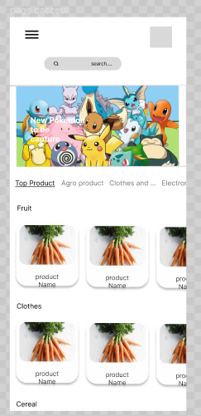

Here the Customer views all the products which are already in category

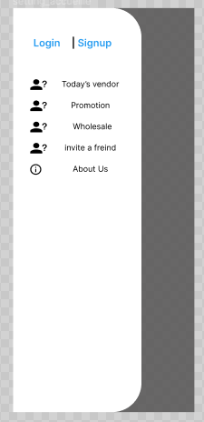

Here the Customer has the ability to view the vendor that just posted and some promotions and even to invite friends.

* **Search Product**

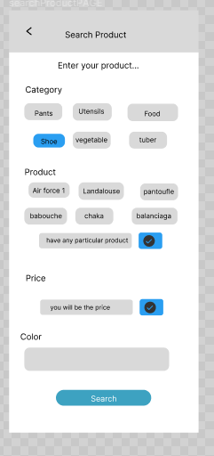

The Customer is able to search a product based on the category

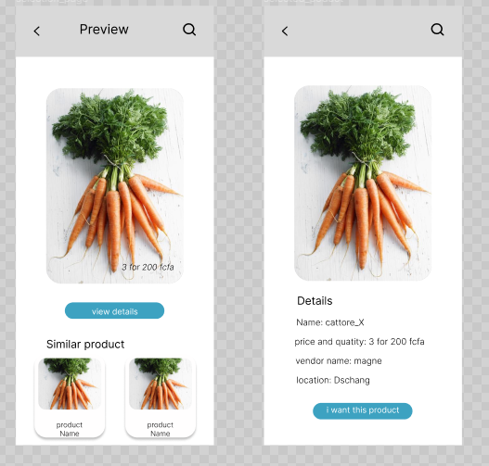

As we can see there is a first part concerning the preview where the customer can view a product and products similar to it, also he is able to view details about the product like Vendor, prices and quantity, location and product name.

* UI/UX Design for Vendor:

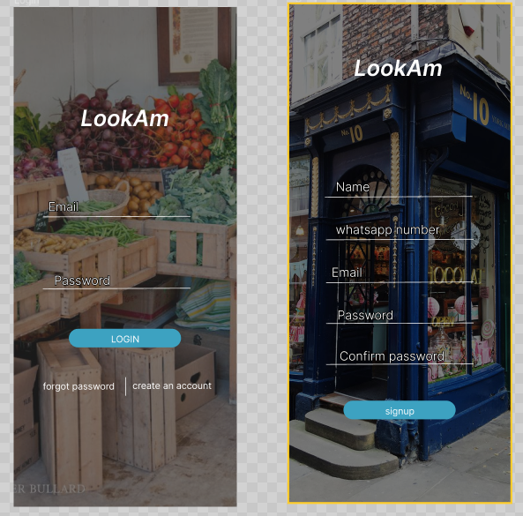

The Vendor can Sign-up or Login. In case the Vendor has forgotten his or her password there is a Two way authentication so as to check the if the Vendor exists in the System, and it’s design is as follows;

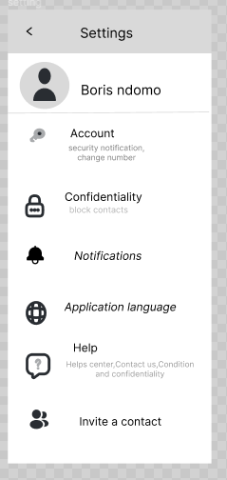

This Screen is the setting Screen which has several functionalities such as Account; for a Vendor to view his or her account.

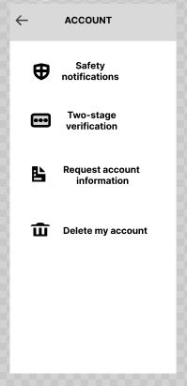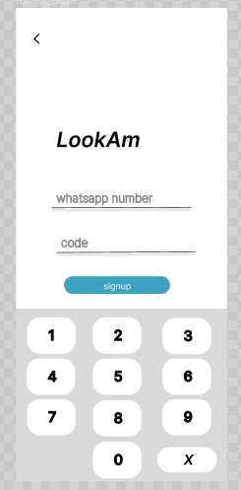

**Account**: Here the Vendor is mainly able to delete his or her account , request information about the account from the system.

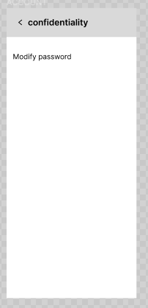

Confidentiality: The Vendor has the ability to modify his or her password,

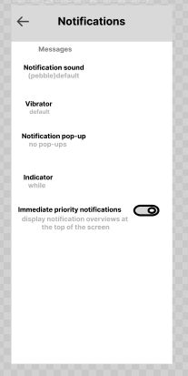

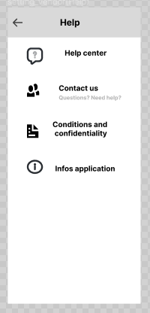Notification: where the vendor has the ability to modify the notification sound, App Language,

Help; so as to get help from the system or the individual behind the System,

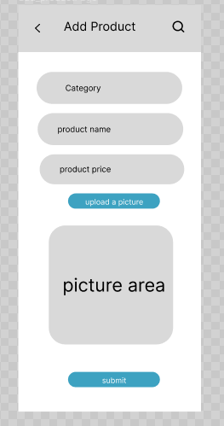Invite a contact

The Vendor is able to Add a product

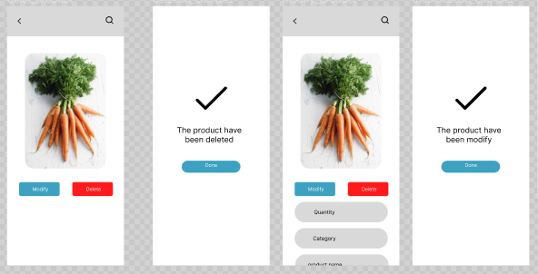

The Vendor is also able of Modifying and Deleting a Product, and the System Displays Notifications

**Interaction Design:**

Interaction design played a vital role in creating a seamless and intuitive user experience within the Market Management System. User flows, task scenarios, and user journeys were meticulously crafted to guide market managers through their tasks efficiently. Interactive elements, such as buttons, forms, and data input methods, were designed to provide instant feedback, reducing errors and enhancing user confidence.

**Usability Testing and Evaluation:**

Usability testing sessions were conducted to evaluate the effectiveness and efficiency of the UI/UX design. Real market managers were given specific tasks to complete within the system, and their interactions were observed and analyzed. User feedback and quantitative data were collected to identify pain points and areas for improvement. The iterative testing and evaluation process ensured that design decisions were based on user needs and preferences.

**Conclusion:**

In conclusion, the UI/UX Design Report demonstrates the thorough design process undertaken to create an intuitive and user-friendly Market Management System. By conducting user research, developing a logical information architecture, implementing a visually appealing design, and prioritizing interaction design, we have created a system that empowers market managers to efficiently manage markets, make informed decisions, and drive success.

Through usability testing and evaluation, we have gained valuable insights and made iterative improvements to enhance the user experience further. The Market Management System's UI/UX design is poised to deliver a seamless and enjoyable experience for market managers, positioning our company as a leader in market management solutions.

Continued user feedback and a commitment to ongoing refinement will ensure that the Market Management System remains a valuable tool for market managers, meeting their evolving needs and exceeding their expectations in the dynamic market environment.

To get access to our figma design, follow the link below;

[Untitled – Figma](https://www.figma.com/file/fkAbSLV4OvYHtKNkvFQYGJ/Untitled?type=design&node-id=0-1&t=mpWDm0vA2qp80zo4-0)

**LOOKAM IMPLEMENTAION REPORT**

**Implementation of the vendor side**

* **Login**

Here, the vendor is asked to enter his credentials that is email, password to permit him enter the platform.

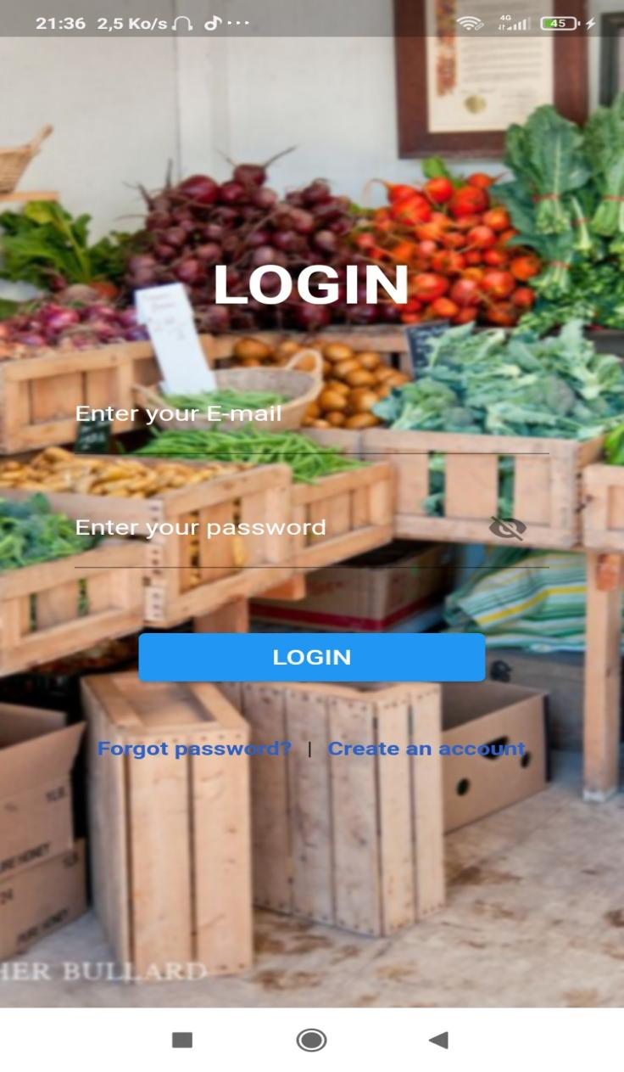

* **Create an Account**

Here, for a new vendor to enter in the system his is asked to enter some register and this is done by the him entering his email, password and follow the instruction.

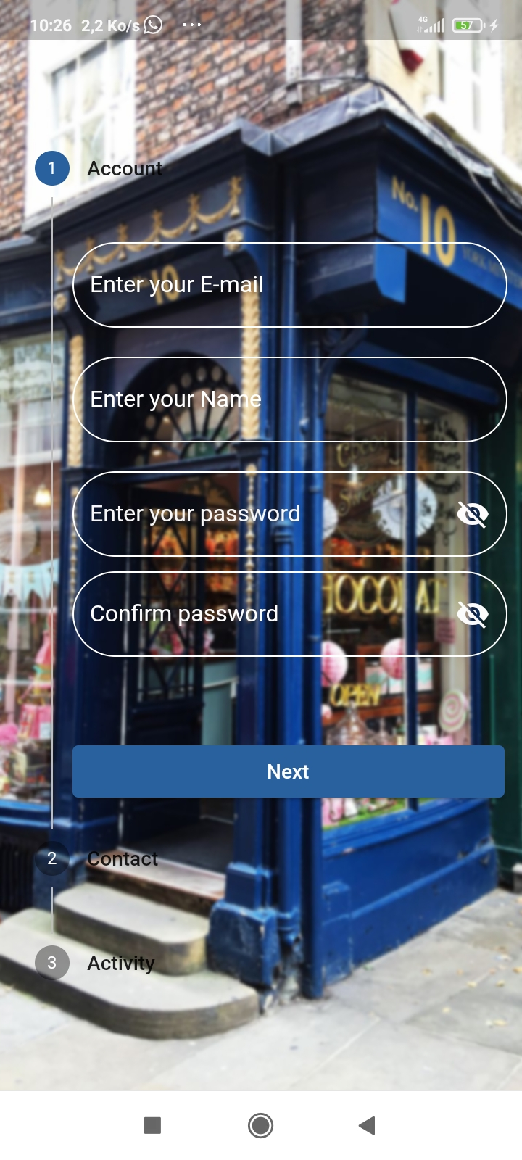

* **Forgot password**

Here, in case a vendor has forgotten his password he has the possibility of changing his password by the use of this page.

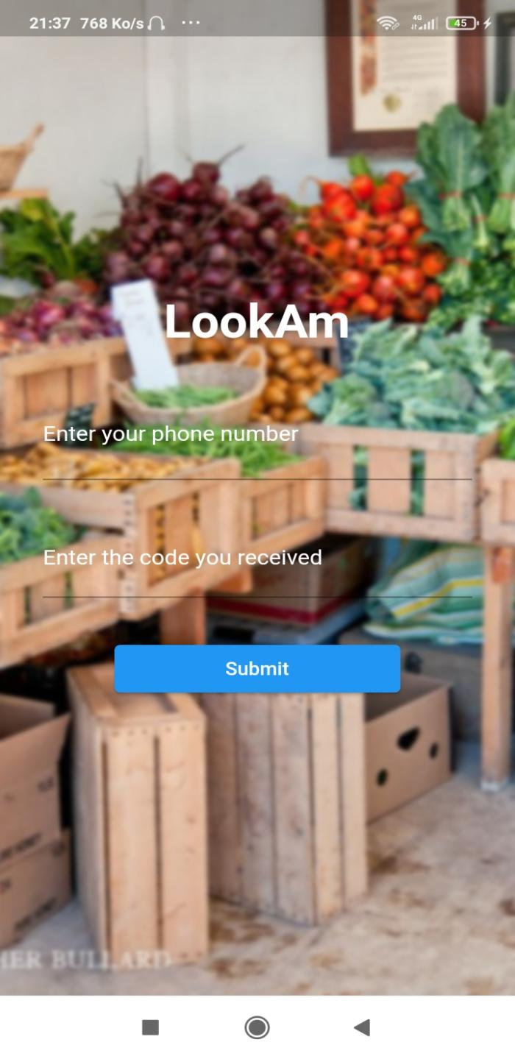

* **Home**

It is also called the menu page because from there he has the ability to view all the different pages of navigation.

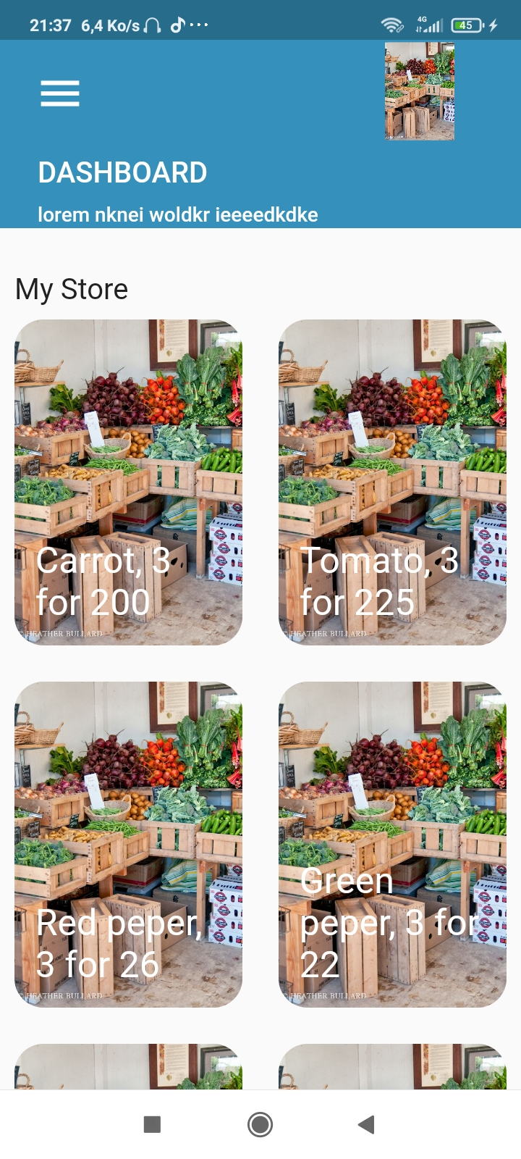

logo

**Variable**

The variable use in this page are:

**Product**: it is a list of map(list of structure) without define length that help to store all the product of a vendor. Those product are store by name,category,price, quantity and image(avatar in our case).

- **haveBeenTapped**: it is a boolean variable that help us to tell is the last card have been tapped or not

-**Appbar**

-**Body**.

The home page of a vendor help the vendor to view all the product he have posted on his space. It display the products in form of card that contain the image of the product, the name, the price, quantity and category. The card are been displayed using a GridViewList allowing us to display two product on the same row.

To easy the configuration of the GridViewList( number of card to display, what should be display if the last card have been tapped), we make use of 3 function of type int. This function are:

- int rest( int b): this function have an integer as parameter and it is for calculating the rest of element in the list that have not been display initially.

- int counter(bool a, int b): this function help us to change the number of element that should be display. This variation is produict when the vendor tap on the last element that have been display for he to see the rest of element or product he have in the database.

- int indet: this function help us to indicate the last element of the list that will have the role of causing the display of element that have not been display.

* **Bottom sheet**

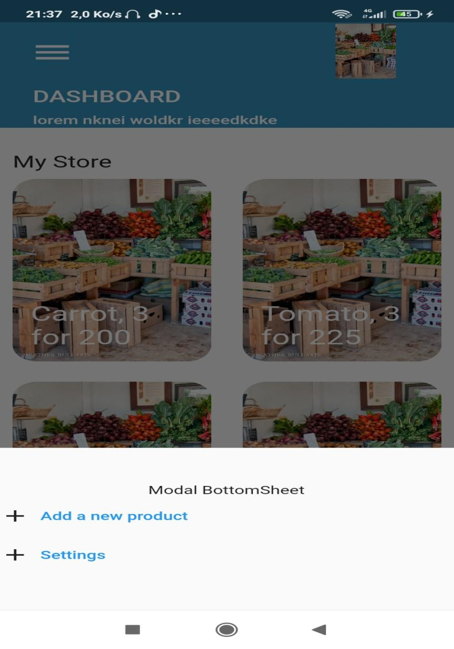

The element on the bottom sheet are text bottom, here the vendor has the ability to see his current product and also the navigate from one page to another and this was done with the syntax **SHOW MODAL BOTTOMSHEET.**

* **Add Product**

Here, the vendor has the ability to add product in the application.

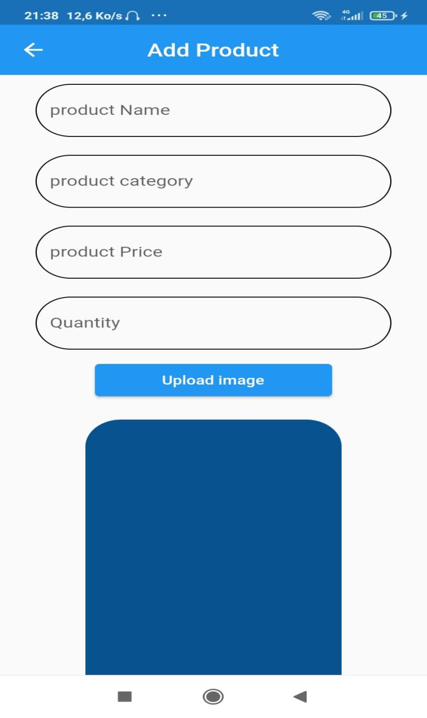

* **Modifier/ Delete product**

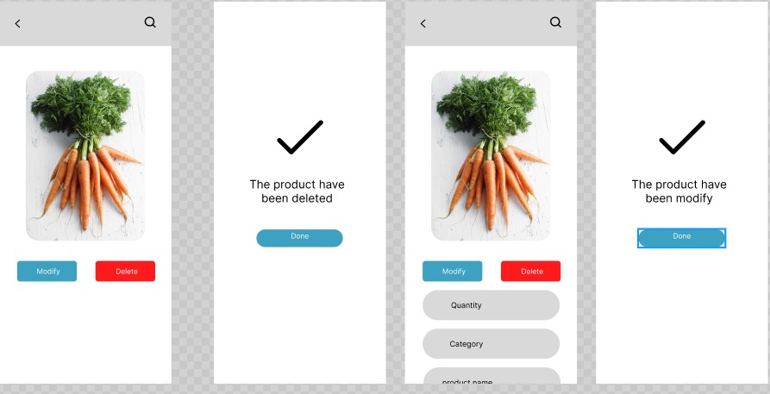

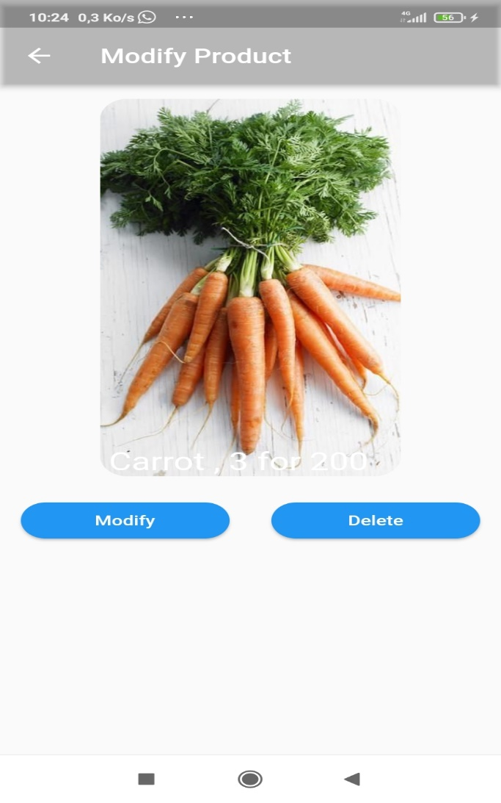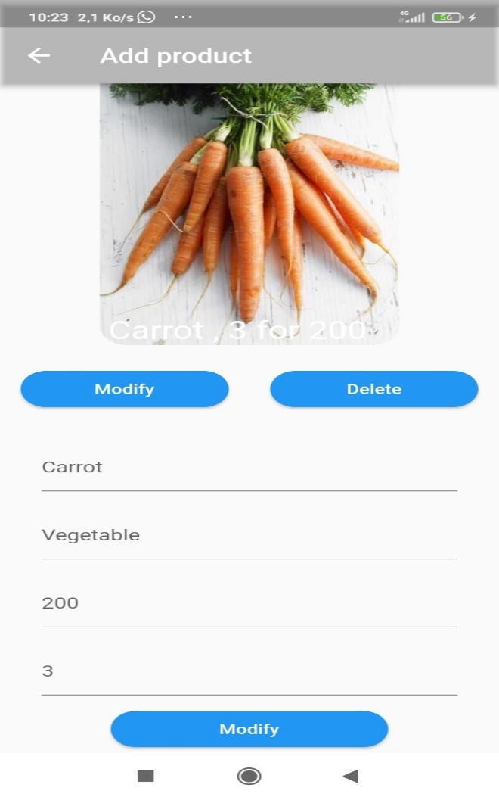

Here, after an item have being selected all it characteristics are shown and the vendor has the opportunity to delete or modify it.

**Implementation of the Customer side**

* **Home**

The home page of the customer side, is the main (first) screen of our application.

This page is built to help the customer to see all the different goods and items that is offered to him by the vendor.

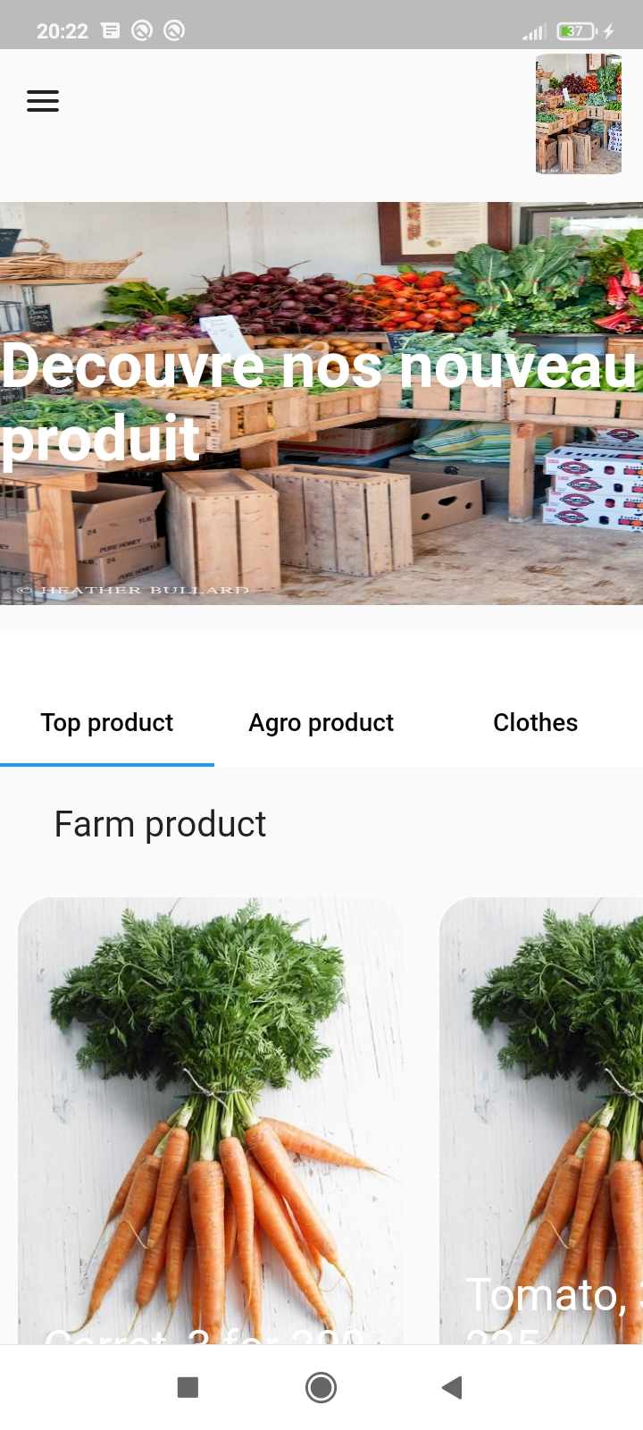

Card: the are the representation of the product in the system. The display the image and price of the image, in some categories , it also display the quantity. This is the case with the Argo product category

Carousel: it is a reserve for advertisement on the application. It display different images after a periode of time

Tab Bar: it help us to display the various category of product in the system. The views of this Tab bar are build on a different page. All this pages have the same configuration but display product according to their purpose.

logo

Menu icon: this is a button icon that when click, it open the side sheet of the application

* **Search page**

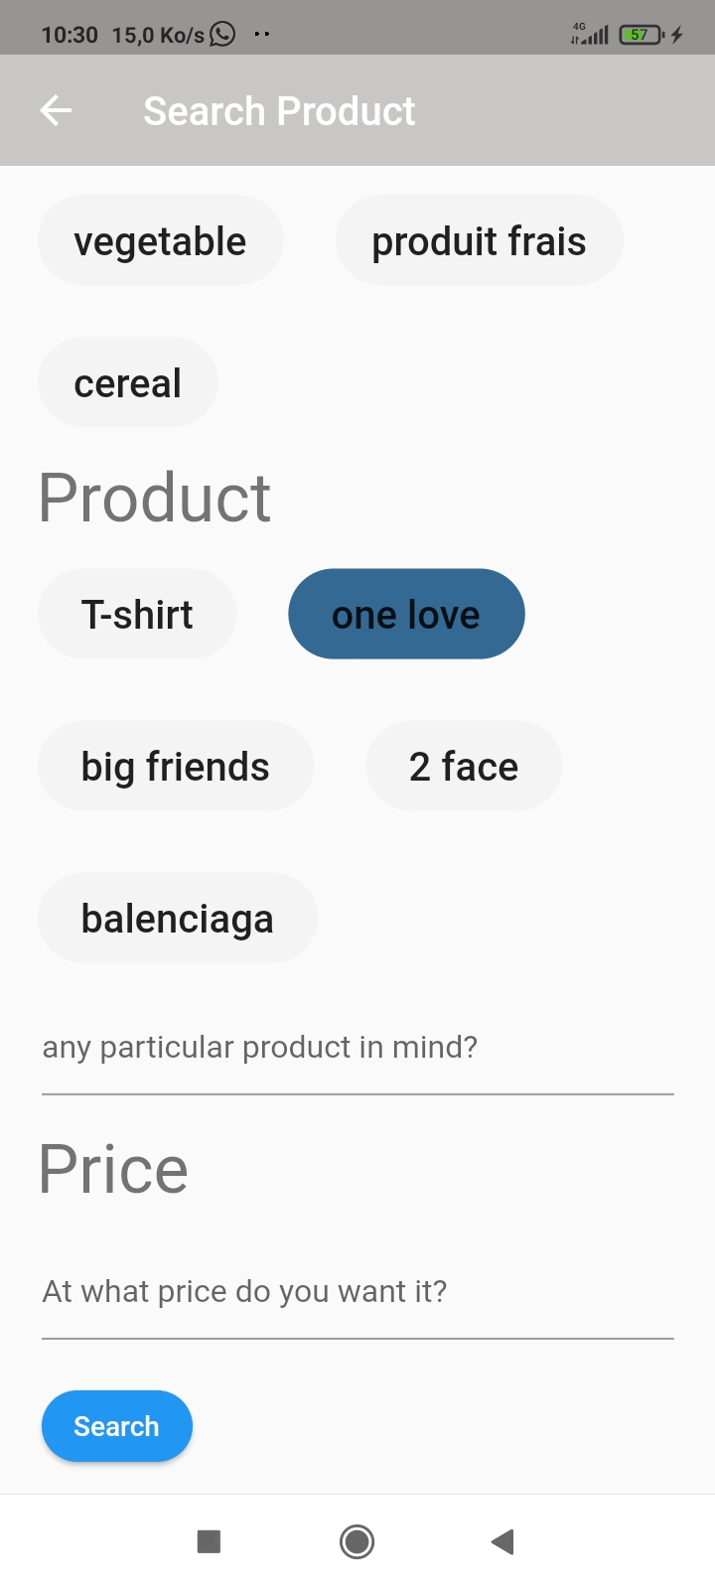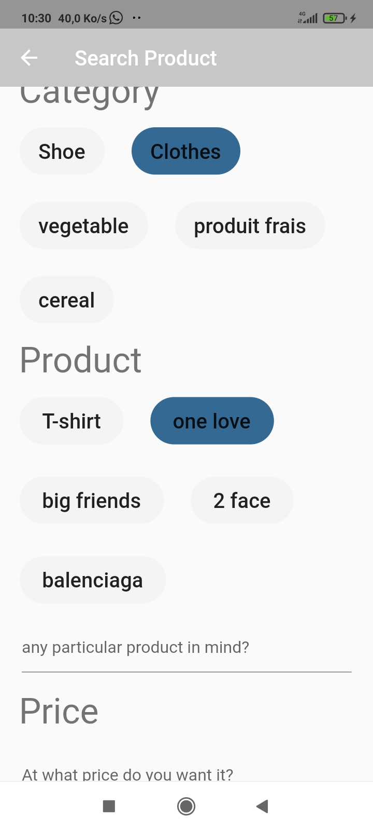Concerning the search page it’s a page where customers has the ability to well filter their needs in terms of articles. That is they have the ability to put his price and choose the color, as it can be seen on the diagram;

* **Sign up button**

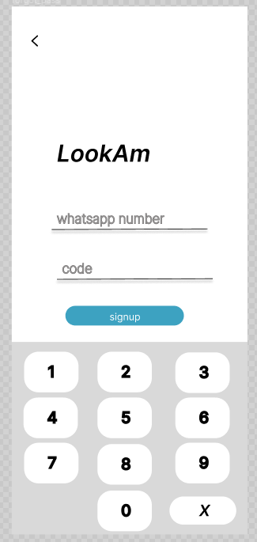

Here, the vendor has the ability to enter in the app to by the use of his phone number where a code will be send to him in a message form. In case where the code is wrongly written or not written at all when the button **signup** will be press an error message will pop out and this was done with the use of a **Global Key.** And we made use of a **REGEX** to be able to regulate the size of the number depending on the country.

* **Info**

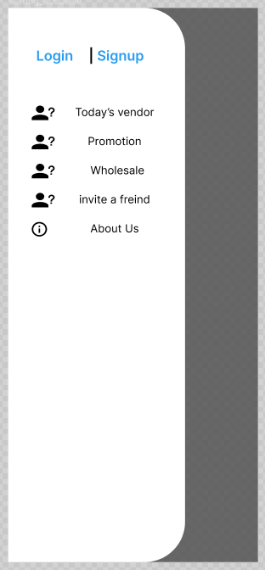

Here, the customer has the ability to have info on a vendor, to get the different promotion of the day and even to invite friend to join the community.